# 3. Results and discussions

## 3.1 Model validation

## 3.2 Effect of Ra

 

图1 a完全融化时间 b 熔化改善效率（

According to Figure 1a, the complete melting time (t) of an equal volume of paraffin wax decreases with increasing Rayleigh number (Ra) when applied to both the left wall and the bottom surface. For instance, when heating the left wall, the complete melting time (tA1) for Group A1 (Ra=1000) is 94.61% of the value observed for Group A28 (Ra=100000). Additionally, under the same Ra, the complete melting time for bottom surface heating is significantly shorter than that for left wall heating, indicating higher melting efficiency when choosing the bottom surface of the PCM cavity as the heating boundary. This is because the direction of buoyancy and heat is parallel, promoting the melting process of PCM into the liquid phase when heating the bottom surface. In contrast, when the heat flux is applied to the upper wall and Ra<40000, the complete melting time shows a sinusoidal upward trend.(这段怎么解释) This phenomenon can be attributed to the fact that under upper wall heating, the direction of heat transfer is opposite to that of buoyancy, hindering the liquid phase process of PCM. However, with the increase of Ra, the stronger convective heat transfer capacity enhances the effect of buoyancy on downward heat transfer, resulting in a general upward trend in the melting time.

Figure 1b further demonstrates the improvement in melting efficiency (， is the corresponding heating melting time of the lower wall) achieved by bottom surface heating. Based on multiple simulation results, η increases with increasing Rayleigh number. Compared to left wall heating, Group A1 (Ra=1000) exhibits the lowest improvement efficiency (approximately 2.16%), while Group A28 (Ra=100000) shows the highest improvement rate (approximately 5.61%). Similarly, compared to upper wall heating, Group A1 (Ra=3000) demonstrates the lowest improvement efficiency (approximately -0.2%), while Group A28 (Ra=100000) exhibits the highest improvement rate (approximately 11.1%). These results indicate a significant enhancement in the melting rate of the PCM cavity when the bottom surface is heated.

图2 全局平均温度



a左壁面加热 b 下壁面加热



c 上壁面加热

Figure 2 illustrates illustrates the correlation between the global average temperature of the phase change material (PCM) within the square cavity and the Rayleigh number for various heated wall surfaces. As the Rayleigh number increases, the cavity's average temperature generally experiences an initial decrease followed by stabilization. Specifically, when the upper wall is heated, the temperature demonstrates the slowest rate of change with respect to the Rayleigh number, whereas the rate of change is highest when the lower wall is heated. This suggests that the selection of different heating wall surfaces significantly impacts the melting process of the PCM within the cavity, particularly when the lower wall is chosen for heating, resulting in an accelerated PCM melting process within the cavity. It is worth noting that temperature fluctuations occur when a sinusoidal heat flux is applied to the lower wall within the Rayleigh number range of 0-10000 and 35000-45000, respectively.

Overall, the results indicate that increasing the Rayleigh number leads to shorter complete melting times and improved melting efficiency when the bottom surface is heated, indicating higher melting efficiency due to the alignment between heat transfer direction and buoyancy. Additionally, temperature fluctuations occur when a sinusoidal heat flux is applied to the lower wall, and the average temperature in the cavity stabilizes as the Rayleigh number increases, with the highest rate of change observed when the lower wall is heated.

Figure 3 局部T-t



3 a 左壁面加热T



3 b 下壁面加热T



3 c 上壁面加热

To further illustrate the impact of the Rayleigh number on the PCM melting process under different heated wall surfaces, Figure 3 depicts the localized temperature variations at the heating wall location. The findings indicate that with increasing Rayleigh number, the temperature decreases at the same heating instance. For example, when the lower wall is subjected to the heat flux, the temperature variation curve diverges, forming a temperature plateau at t=3. As the Rayleigh number increases, the occurrence of this plateau advances, and its duration prolongs. For instance, when the lower wall of the cavity is heated (corresponding to the lower-left region), at a Rayleigh number of 5000, the plateau emerges at time t1=7.71 and persists for t2=9.43. As the Rayleigh number escalates to 100000, the plateau appears 4.25 seconds earlier, and its duration extends by 4.06 seconds.

图4 温度场云图（Ra分别为103，104，5*104，8*104，105,t=7时刻）

（a）左壁面加热

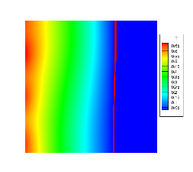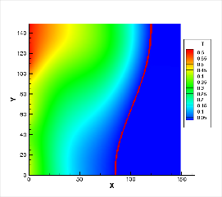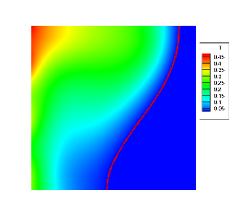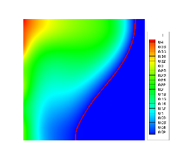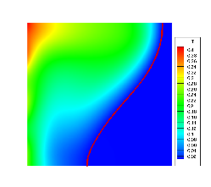

（b）下壁面加热

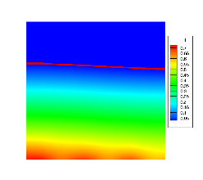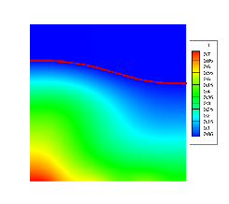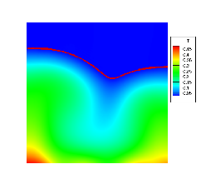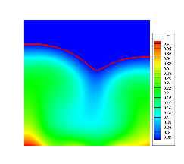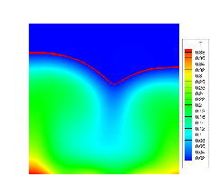

（c）上壁面加热

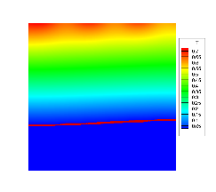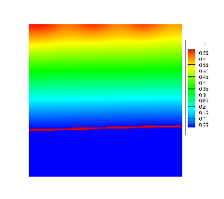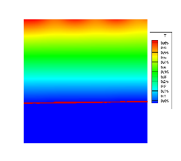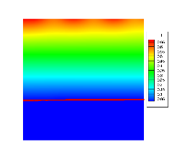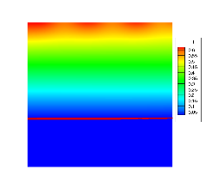

Figure 4 provides further insight into the formation of temperature plateaus. At lower Ra values, heat cannot be efficiently dissipated, as indicated by the temperature contour map, leading to heat accumulation near the heated wall. Within the cavity, conduction is the primary mode of heat transfer, resulting in a rapid rise in the average temperature. The dimensionless temperature exhibits a linear variation across different regions. However, as the Ra number increases, convective heat transfer becomes more pronounced, facilitating the rapid transfer of heat to the solid phase material. This enhances the utilization of latent heat in the solid phase PCM, causing the solid-liquid interface to shift towards the solid phase. Consequently, the dimensionless average temperature increases at a slower rate or reaches a temperature "plateau."

（这里该怎么说上壁面云图区别不大呢）：热对流向上走，对下部相变材料熔化的影响较小。对下半部分而言，还是以传热方式为主，因此云图上显示的变化并不明显。

Overall, the results demonstrate that the selection of different heating wall surfaces and the increase in Rayleigh number significantly impact the melting behavior and efficiency of the PCM within the square cavity. Bottom surface heating proves to be more efficient, leading to shorter melting times and higher melting efficiency compared to left wall or upper wall heating. The alignment between heat transfer direction and buoyancy plays a crucial role in enhancing the melting process. Additionally, the Rayleigh number influences the temperature fluctuations and stability within the cavity, with a higher rate of change observed when the lower wall is heated. These findings provide valuable insights for optimizing the design and operation of PCM-based systems in various applications.

## 3.3 Effect of T

图5 全局液相率及dLF/dt 曲线（此参量的定义在哪里体现？有计算公式否？）

 

左壁面加热

 

下壁面加热

 

上壁面加热

a 全局液相率 b dLF/dt 曲线

In this study, the impact of varying the sinusoidal heat flux period on PCM melting was investigated under specific conditions with Rayleigh number (Ra) set at 50000, Prandtl number (Pr) at 7, Stefan number (Ste) at 0.1, and sinusoidal amplitude at 0.5. The heated wall surfaces considered were the upper, lower, and left walls. The research aimed to explore the effect of different sinusoidal periods on PCM melting under a constant total heat input.

Figure 5a illustrates the variation of liquid fraction (LF) /t under different sinusoidal periods. Notably, during the melting process, the LF curves for both high and low temperature groups exhibit a distinct crossover phenomenon. To gain deeper insights into the melting process, the first derivative of LF with respect to time (dLF/dt) was computed and presented in Figure 5b, providing valuable information on the PCM melting rates. Although there were observable individual variations due to different heating surfaces and periods, an overarching trend was observed in dLF/dt, showing an initial rapid decrease, followed by a stable fluctuation, and then intense fluctuations before reaching a stable stage. This intriguing behavior is primarily attributed to the unique thermal phenomena exhibited during each of the four distinct stages of the solid-liquid phase transition process.

图6 下壁面加热时不同周期的dLF/dt曲线及对应阶段

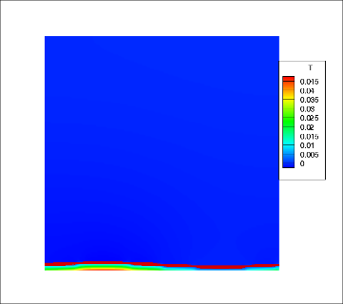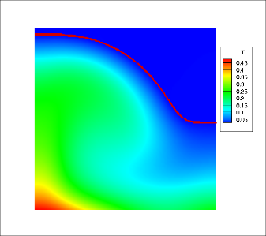

T=1 A B

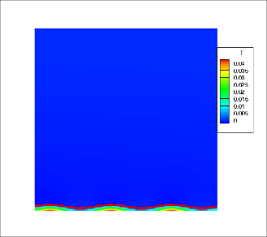 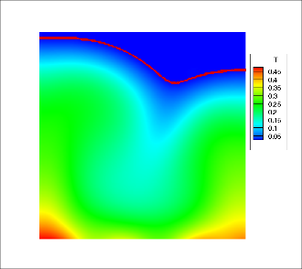

T=3 A B

 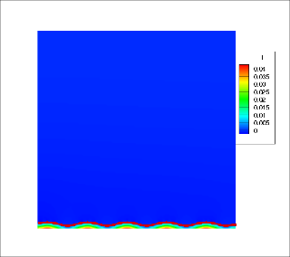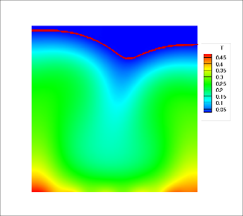

T=5 A B

6a 导数图 6b 温度云图

In Figure 6a, three typical dLF/dt curves with sinusoidal periods of 1, 3, and 5 are presented when the heating wall is the bottom wall, illustrating four distinct stages of the melting process. During the first stage (Stage I), heat is transferred from the wall to the PCM in the cavity. Prior to point A, heat conduction dominates as the PCM inside the square cavity begins to melt, resulting in the steepest slope in the corresponding dLF/dFo curve. The temperature contour map at point A indicates different distributions of PCM temperature and solid-liquid interface line corresponding to the varying periods.

After point A, the second stage (Stage II) commences, with natural convection gradually intensifying. Buoyancy-induced natural convection becomes evident, leading to the elongation of the solid-liquid interface towards the deeper part of the cavity. Heat transfer in this stage is a combination of conduction and convection, resulting in a smoother dLF/dt curve. Upon reaching point B, the melting rate reaches its peak, marking the onset of the third stage in the phase transition process (Stage III). During this stage, heat transfer primarily occurs through natural convection, causing the melting rate to decrease until all the solid-phase paraffin inside the square cavity is completely melted. Subsequently, the process enters the fourth stage (Stage IV) of the phase transition, where heat is entirely stored in the form of sensible heat, leading to an overall temperature increase.

However, when the bottom wall is heated, the duration of Stage II decreases as the sinusoidal heat flux period increases. The durations for periods of 1, 3, and 5 are 7.71525, 8.61332, and 8.86824, respectively (see Figure 6b). By examining the temperature contour map at point B, it is observed that with an increase in the period, the right-side solid-liquid interface elongates upwards. This behavior can be attributed to the fact that the right side of the cavity experiences a sub-cycle of sinusoidal heat flux when the period is 1, resulting in a lower heat flux density, which leads to a slower temperature rise. However, as the period increases, the heating in this region becomes more balanced, resulting in a more uniform heat distribution and a more stable temperature profile.

图7 LF of different T at stage III during left wall heating

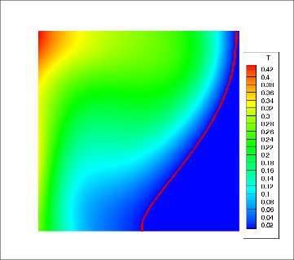 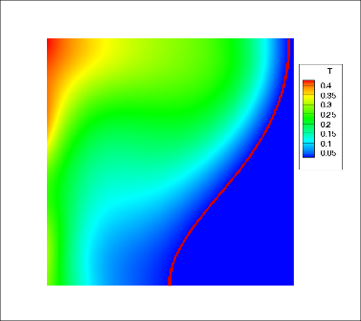 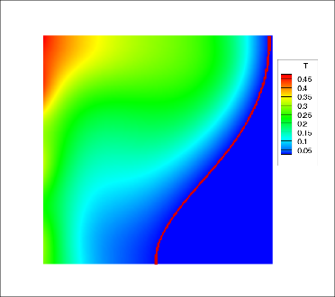

T=1 T=2 T=3

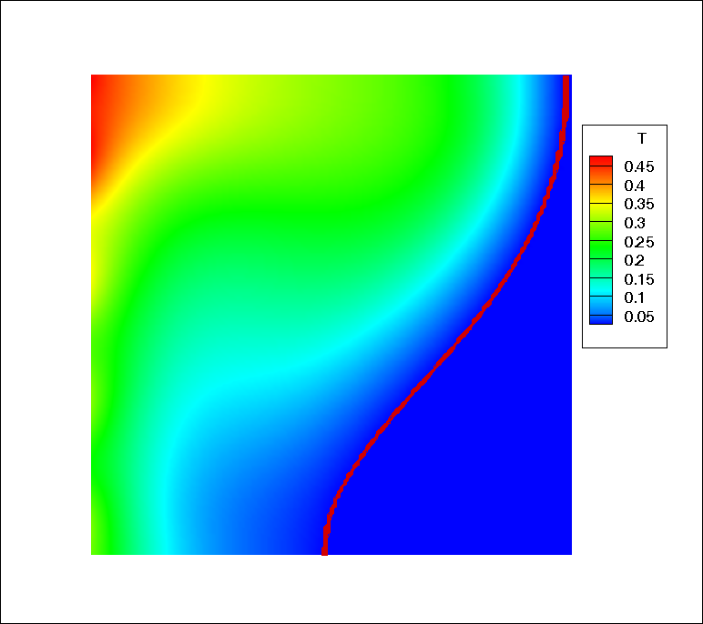 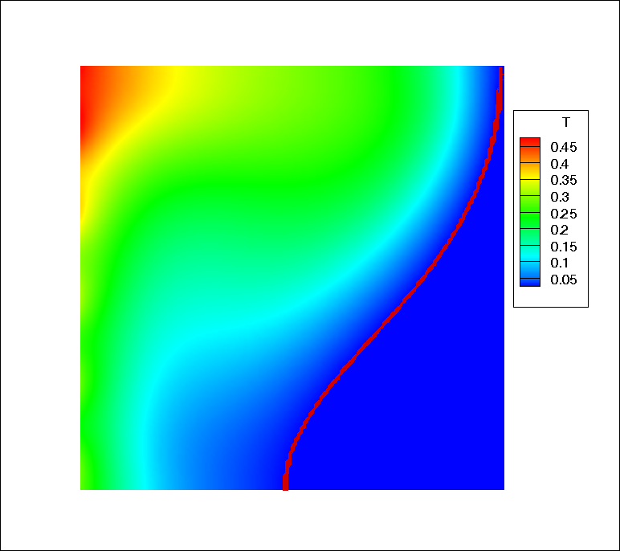

T=4 T=5

In Figure 5b, it can be observed that unlike the situation with lower wall heating where the peak of Stage III occurs later as the sinusoidal heat flux period increases, when the left wall is chosen as the heating surface, the peak of Stage III occurs earlier with the increase in the period. For five different periods (T=1, 2, 3, 4, 5), the duration of Stage III increases by 0.292, 1.174, 1.464, 1.719, and 1.85, respectively, compared to the case of lower wall heating.

As shown in Figure 7, as the period increases, the inclination of the solid-liquid interface becomes steeper, which is attributed to the clockwise convection that brings heat to the upper region. A larger period enhances the circulation, causing a faster rise in the dimensionless temperature in the upper region.

Overall, this study investigated the influence of varying sinusoidal heat flux periods on PCM melting under specific conditions (Ra=50000, Pr=7, Ste=0.1, Amplitude=0.5). The research revealed the distinct impacts of different heating wall surfaces on the stages of the melting process. When the bottom wall was heated, longer periods led to more balanced heating and a stable temperature distribution. Additionally, the study highlighted the effect of clockwise convection on temperature distribution when the left wall was chosen as the heating surface.

## 3.4 Effect of A（Amplitude写全称比较好）

In this section, the impact of varying sinusoidal heat flux amplitudes on PCM melting was studied under specific conditions with Rayleigh number (Ra) set at 50000, Prandtl number (Pr) set at 7, Stefan number (Ste) set at 0.1, and sinusoidal period set at 3. The heated wall surfaces considered were the upper, lower, and left walls. The research aimed to explore the effect of different sinusoidal amplitudes on PCM melting under a constant total heat input. The statement has been revised for clarity and conciseness, maintaining the necessary technical information while improving readability.

图8 全局液相率及dLF/dt 曲线



左壁面加热

 

下壁面加热

 

上壁面加热

a 全局液相率 b dLF/dt 曲线

From Figure 8b, it can be observed that the impact of increasing the amplitude on the PCM melting process varies depending on the selected heated wall. When the bottom wall is heated, the increase in amplitude leads to an earlier onset of the third phase transition. The starting times of the third phase transition for different amplitude groups, A1 (A=0.1), A2 (A=0.3), A3 (A=0.5), A4 (A=0.8), and A5 (A=1), are t1=9.24, t2=8.99, t3=8.77, t4=8.41, and t5=8.15, respectively. However, under the condition of left wall heating, increasing the amplitude results in a delayed onset of the third phase transition.

图9 下壁加热过程中第三阶段不同振幅的LF云图(a)A=0.1； (b)A=0.5； (c) A= 1。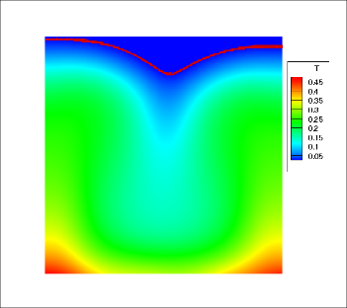 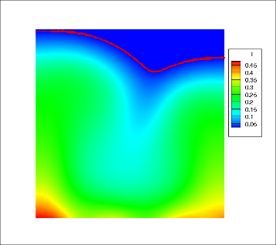 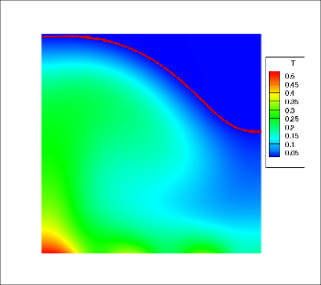

a A=0.1 a A=0.5 a A=1

As shown in Figure 9, when the bottom wall is heated, with an increase in the sinusoidal amplitude, the high-temperature region on the right side of the cavity decreases. During the melting process, natural convection becomes the dominant heat transfer mechanism at an earlier stage. With the increasing amplitude, the influence of sinusoidal heat flux on the temperature distribution becomes more pronounced, promoting the mixing and enhancement of circulation in the phase change material (PCM). The advancement of the third stage of phase change can be understood as a result of the interaction between buoyancy and evolving temperature gradients. As the high-temperature region becomes smaller and more dispersed, buoyancy-driven flow patterns occur earlier during the melting process, facilitating heat transfer throughout the cavity.

The PCM melting processes under different heating wall conditions are illustrated in Figures 10 and 11. At the same liquid fraction, increasing the amplitude has distinct effects on left wall heating and bottom wall heating.

For bottom wall heating, as the sinusoidal amplitude increases, the solid-liquid interface exhibits a more pronounced rightward tilt. This phenomenon can be attributed to the orientation of buoyancy-driven flows and the interaction between the sinusoidal heat flux and the heating surface. The increased amplitude intensifies the flow circulation and promotes deeper heat penetration, leading to the observed rightward tilt of the solid-liquid interface.

左壁面那个不太会分析了。。

图10 底壁加热期LF = 0.5/0.8 时液体分数轮廓，(a)A= 0.1; (b)A= 0.5; (c)A= 1.

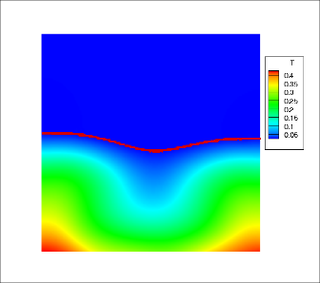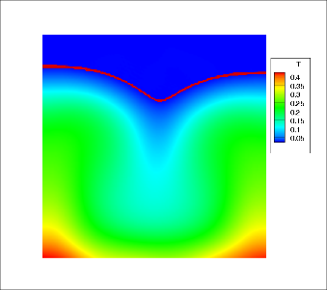

1. A= 0.1

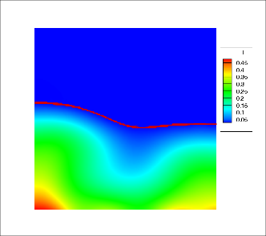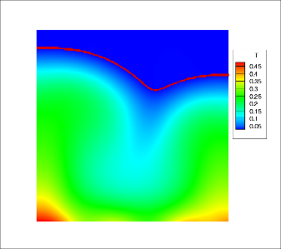

1. A= 0.5

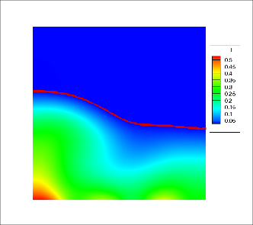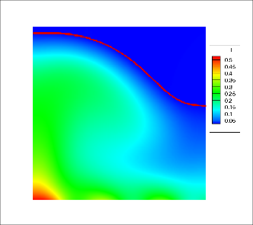

1. A= 1.

图11 左壁加热期LF = 0.5/0.8 时液体分数轮廓，(a)A= 0.1; (b)A= 0.5; (c)A= 1.

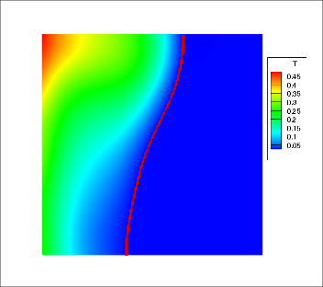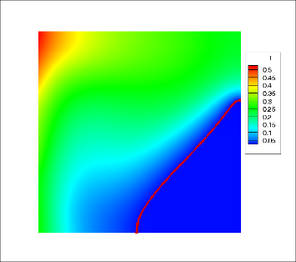

1. A= 0.1

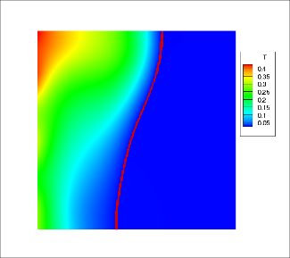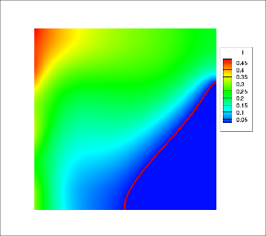

1. A= 0.5

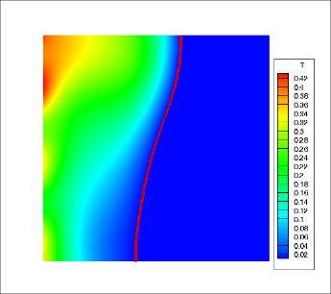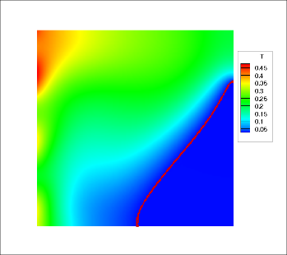

1. A= 1.

# 4. Conclusion

This study investigated the impact of varying sinusoidal heat flux period and amplitude on PCM melting under specific conditions. The findings provide valuable insights into the melting behavior and efficiency of PCM within a square cavity, considering different heating wall surfaces and Rayleigh numbers.   
 For bottom wall heating, increasing the sinusoidal amplitude resulted in a remarkable reduction in the complete melting time (t) of PCM, indicating enhanced melting efficiency. This improvement can be attributed to the alignment between heat transfer direction and buoyancy, facilitating the PCM melting process into the liquid phase. Conversely, for left wall heating, increasing the amplitude led to a decrease in the tilt of the solid-liquid interface   
 Moreover, the Rayleigh number (Ra) significantly influenced the PCM melting process. Higher Ra values led to shorter complete melting times and improved melting efficiency, particularly evident in bottom surface heating. Temperature fluctuations occurred at specific Ra ranges when sinusoidal heat flux was applied to the lower wall.   
 The results underscore the importance of considering sinusoidal heat flux parameters and heating wall choices in PCM-based systems design. Bottom surface heating proves to be more efficient, resulting in shorter melting times and higher melting efficiency. Understanding the interplay between thermal gradients and fluid dynamics is crucial for optimizing the PCM melting process. These insights contribute to the advancement of PCM applications, providing valuable guidance for energy storage and thermal management systems. Future studies should focus on investigating the underlying mechanisms of PCM melting under diverse conditions and exploring innovative strategies to further enhance melting efficiency for practical applications.